Leveraging Subtitling and Captioning of Videos to Optimize Language Learning

People often access foreign language audio-video media with the help of subtitles (i.e., textual translation in the viewer’s first language—the L1—or a more familiar language). Similar to subtitles are captions, with the important difference that captions are transcriptions of the original language without translation (i.e., text in the same language as the audio, the L2).

Viewing audio-video media with subtitles facilitates learners’ access to cultural images, concepts, and practices through film. Given the benefits of presenting engaging authentic media to beginning learners’ motivation and affect, subtitled media can be a valuable tool for recruitment and retention.

Use of captions with target language audio-video media, i.e., presenting the target language simultaneously in audio and text, has clearly documented benefits for learning target language vocabulary. At relatively early levels of exposure, watching target-language captioned videos can yield significant improvements in speech segmenting ability in a matter of weeks (see, e.g., the study of A2-B1 learners of German by Peltekov, 2022), with additional benefits to learner affect.

Opportunities for Learning with Captions and Subtitles

- Tracking Differences

For commonly taught languages, many types of authentic media, such as feature length films, may be disseminated with English, French, or Spanish subtitles and/or closed captions in the target language intended for use by hearing impaired audiences. Even such professionally produced subtitles and captions often differ from the spoken lines of the audio track, while typically maintaining a similar general meaning. In other media such as online videos, automatically generated captions often contain numerous errors as well. Noting specific differences in grammatical forms, vocabulary, phrasing, or idiomatic usage between audio and text can serve as a valuable attention-focusing exercise for learners to reflect on the language and its uses.

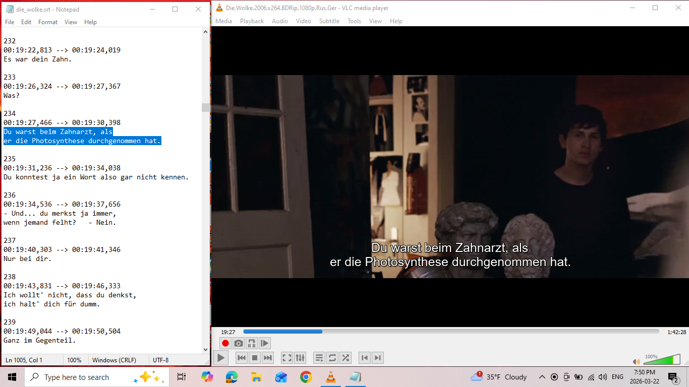
Sample image of self-made .SRT file captions alongside Die Wolke (2006) VLC Player.

- Correcting or Composing Captions

Correcting or composing captions provides an opportunity for learners to demonstrate their target language linguistic competence in context by identifying discrepancies and composing a correct captioning transcript. Discrepancies between captions and audio can arise from automated captioning or from differing transcripts in professional production. Additionally, a great deal of authentic online media (e.g., livestreams, YouTube shorts) lack captioning entirely. Even some professionally produced films lack closed captioning features, especially those intended only for domestic audiences or young people, or those by independent producers (e.g., the 2006 German young adult film Die Wolke [The Cloud], which lacks German captioning, English subtitles and dubbing). Close listening exercises or projects with such videos or films offer learners the opportunity to apply their linguistic ability for the communicative purpose of producing a transcript of captions to authentic media. For small groups or beginners, completion of captions for a short video (e.g., YouTube, TikTok) is an achievable project scope. For intermediate or advanced learners, especially for larger groups, longer media forms such as a short film may be feasible, depending on the pace, difficulty, and variety of dialogue. Given sufficient time to work, access to necessary resources (e.g., dictionaries), and an appropriate project timetable, a cohort may be able to prepare captions for an entire feature-length film.

- Correcting or Composing Subtitles

Many easily accessed forms of authentic video media are produced without subtitling of any kind, as they are intended only for a target language audience. As with closed captioning, professionally produced subtitles or audio dubbing may significantly differ from the denotative meanings or cultural connotations of the audio script in the original language. For example, in the Spanish production of Star Wars: Episode II – Attack of the Clones (Star Wars: Episodio II - El ataque de los clones), dialogue between Anakin and Padmé includes certain vocabulary and prosody of a telenovela style that emphasize the “young” in young adult romance, seemingly to invite the audience to snicker more than the original English performance. For many films, similar discrepancies between the original language of the audio or closed captioning and translations used for subtitles may offer opportunities to explore comprehension and cultural context. For advanced learners, producing subtitles in their own L1 or another familiar language for a video or film that lacks them creates an opportunity for integrated reflection on linguistic forms and cultural meanings.

Accessible Tech: Homemade Captions and Subtitles

Making your own captions or subtitles is readily achieved with free software on common computer systems. All that is needed is a video saved to a common file format (e.g., .MP4), a video player (e.g., Windows Media Player, VLC Media Player), and a text file editor (e.g., Notepad).

The .SRT File Format
The most commonly used caption file type is the .SRT (SubRip Text), which is a plaintext file format similar to a .TXT (Text) file, but with the .SRT filename extension. The University of Texas—Austin has published a brief guide to using .SRT files in conjunction with a video file (.MP4) and VideoLAN’s VLC Media Player, a common free and Open Source video player for Windows, MacOS, or Linux systems. In short, to play homemade captions in an .MP4 file, you need to (a) give the .SRT file the same name as the .MP4 file (except for the file extensions), (b) have both files saved in the same folder on your computer, and (c) open them together. (In some players, such as Windows Media Player, you can “turn on” the caption file using the captions tool on the tool bar in the video player.)

Editing the .SRT File
Each caption or subtitle in an .SRT file has the following format (left):
202  00:16:39,078 --> 00:16:40,641  Wait here for Hannah, all right?  203  00:16:40,886 --> 00:16:42,625  She'll take you to school.  204  00:16:46,719 --> 00:16:49,220  I'll call you guys today  before bedtime, hmm? | Counter for each Caption/Subtitle  Time Range (beginning and end time)  Caption/Subtitle Text (1 or more lines)  Blank Line (divides captions/subtitles)  Time Range format  HH:MM:SS,mmm  Hours, Minutes, Seconds, Milliseconds

There are 4 types of text markup available to adjust the appearance of captions/subtitles, derived from HTML:
Bold: <b>…</b>
Italic: <i>…</i>
Underline: <u>…</u>
Colour: <font color=”color name or color code”>…</font>
It is also possible to relocate the captions on the screen, e.g., for better color contrast against the image, or to avoid overlap with key images or existing captions or subtitles. See Wikipedia for details. For example:
408  00:30:25,380 --> 00:30:27,498  <i>... Networks are now partly overloaded.</i>  - Did Elmar call?  - Who's that? | Italics for background lines on the radio  Non-italics for foreground lines spoken by the characters in the scene’s dialogue

Saving the .SRT File
To save a .TXT file as an .SRT file, rename the file by replacing the file extension. Then when the .SRT file and video file by the same name are loaded together, the captions or subtitles will display over the video as it plays.

Video example: https://youtu.be/Y67Itgc10mA

Captioning/Subtitling Project Ideas
This technique can be put to good use for several types of projects:
- Composing original captions or subtitles for a video that does not have them
- Demonstrating comprehension by captioning in the L2 or subtitling in the L1
- Captioning original target language video projects (e.g., for release on YouTube)
- Incorporating script text directly into a video to aid scoring, despite pronunciation
- Advanced classes preparing authentic audio-video materials for beginner classes

