From Page to Action: Using Textbooks to Create Action-oriented Scenarios


Textbooks are widely used resources in many language classrooms. In some educational contexts, they are required, while in others teachers decide whether or not to use them. Textbooks provide explanations, examples, and activities to help learners practice a language.

Textbooks can be useful, but they also have limitations. In some cases, they can encourage passive learning through static explanations and controlled exercises that don't prioritize authentic communication.

Because textbooks are written for a broad audience, their content may not always feel meaningful to individual learners or reflect their specific needs. They may also present language in a simplified, linear way, disregarding the complexity of language. Additionally, textbooks can become outdated over time.

However, this does not mean that textbooks should be discarded. Instead, they can become useful tools when they are adapted thoughtfully and purposefully to create action-oriented scenarios.

Before exploring how, let’s do a quick review of the action-oriented approach and action-oriented scenarios.
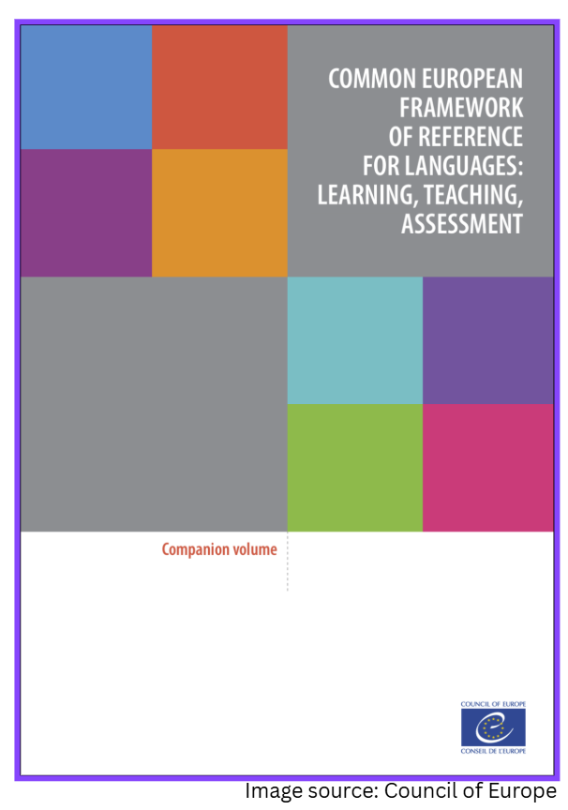
Review of the Action-oriented Approach

The action-oriented approach, or AoA, sees learners as social agents who use language to accomplish tasks.

The AoA was first introduced in the Common European Framework of Reference for Languages, or CEFR, in 2001, and was further extended in 2020 in the CEFR Companion Volume.

The AoA was theorised and extensively developed by Piccardo & North (2019) in their book The Action-oriented Approach: A Dynamic Vision of Language Education.

The AoA brings the CEFR’s descriptive scheme of language proficiency to life by drawing on its descriptors to design action-oriented scenarios.

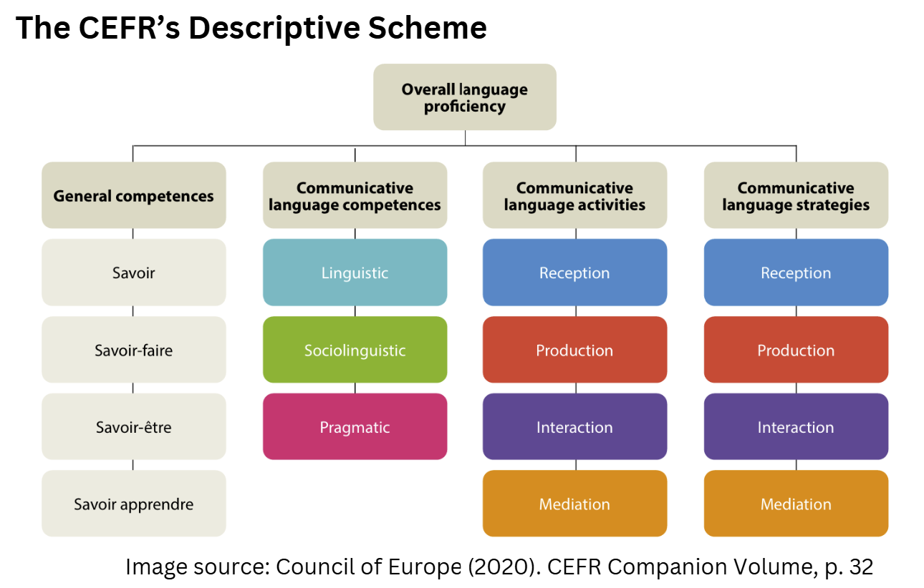

These scenarios function as learning modules, developed through backwards design and implemented over a sustained period of time.

With the AoA, teachers thoughtfully select and combine descriptors to design an authentic and meaningful culminating task that learners complete collaboratively. They then plan a sequence of formative subtasks (or steps) that scaffold the learning process, enabling learners to progressively build the competences needed to successfully complete that final task.

Using textbooks in the development of action-oriented scenarios

Let’s now look at two ways that textbooks can be used in developing action-oriented scenarios.
- Using textbook topics as a starting point
- Using textbook lessons and activities as subtasks


Using textbook topics as a starting point

Textbooks are oftentimes organized around themes such as travel, work, food, or daily life. These topics can be a stimulus for the development of an action-oriented scenario. For example, a textbook unit on healthy living can be a jumping off point for creating an action-oriented task where learners develop and implement a one-week healthy lifestyle plan including meals, exercise, and sleeping habits.

Even textbooks that present final tasks can be bumped up to become more action-oriented. Take for example a task where learners are asked to write and deliver a presentation to their class on their passions. This task can be made more action-oriented by anchoring it more in real-life. For example, learners could create a pitch for a new club at their school based on their passion and could share information about it with a friend in the hopes of them supporting the idea.

Examples of how to transform a task presented in a textbook into an action-oriented task can be found in the Scenarios prepared by the CEFR Eastern Region Working Group in Ontario.

Using textbook lessons and activities as subtasks

Using a textbook does not necessarily mean using it in a linear way. There are many lessons and activities that could be used as subtasks to help build the competences required for the action-oriented task. This includes the teaching of grammar and vocabulary in context.

For example, the section of the textbook that provides a lesson and activities on adjectives would work well as a subtask in a scenario where the use of adjectives are necessary to successfully accomplish the task, such as a task where learners compare different apartments and decide on which one to rent together.

By using textbooks in this flexible way, we can draw on the elements that work well for our learners and integrate them into scenarios that are action-driven, meaningful and purposeful, while encouraging authentic communication and learner agency.

So remember, textbooks don’t need to be followed page by page. They can support action-oriented language learning when they are used flexibly, adapted to learners’ needs, and thoughtfully integrated into meaningful scenarios.

